**Name: Date:**

**Solving Systems of Equations**

**Advanced Algebra**

**Chapter 6: Systems of Equations**

Here is an example of a system of two equations in $x$ and $y$.

$$2x+y=5$$

$$3x-2y=4$$

A _____________________ of this system is an ________________________________ that satisfies each equation in the system.

Finding the set of all solutions is called a **solution set**. For instance, the ordered pair **(x, y)** is a solution of this system.

To check the solution you can substitute ____ for $x$ and ____ for $y$ in each equation.

$2x+y=5$ $3x-2y=4$

-----------------------------------------------------------------------------------------------------------------------------

In this chapter we will study three ways to solve equations, beginning with the **method of substitution.**

Example 1: Solve the following system of equations.

$$x+y=4$$

$$x-y=2$$

Example 2: Solve the following system using substitution. Check your answers.

$$x^{2}-x-y=1$$

$$-x+y=-1$$

Example 3: Solve the following system using substitution. Check your answers.

$$-x+y=4$$

$$x^{2}+y=3$$

Example 4: Solve the following system using substitution. Check your answers.

$$x^{2}+y^{2}=9$$

$$x+y=3$$

Example 5: Graphically Approach to Finding Solutions

The solutions of the system correspond to the **points of intersection** of the graphs.

a. $x-y=2$

$\frac{x}{2}+3y=1$

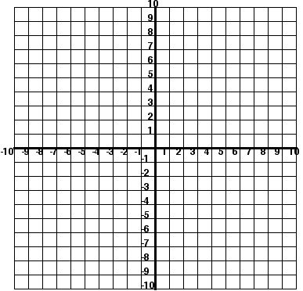

b. $y=x-1$



$y=x^{2}-x-1$

c. $y=x+4$ $y=-x^{2}+3$



**Name___________________________ Date_________________**

**Advanced Algebra Classwork/Homework**

**Solve each Systems of Equations and check your solutions:**

1.   2. 

3.  4. 